**AgriGrow: Intelligent Crop Recommendation System**

Viki Patil

Department of CSE (AIML)

A.P.Shah Institute Of Technology

Thane (M.H), India 400615

[vtpatil@apsit.edu.in](mailto:vtpatil@apsit.edu.in)

Mahesh Pawaskar

Department of CSE (AIML)

A.P.Shah Institute Of Technology

Thane (M.H), India 400615

[mahesh.pawaskar@gmail.com](mailto:mahesh.pawaskar@gmail.com)

Prathamesh Mane

Department of CSE (AIML)

A.P.Shah Institute Of Technology

Thane (M.H), India 400615 [maneprathamesh78@gmail.com](mailto:maneprathamesh78@gmail.com)

Milind Chavan

Department of CSE (AIML)

A.P.Shah Institute Of Technology

Thane (M.H), India 400615 [milindchavan525@gmail.com](mailto:milindchavan525@gmail.com)

Aryan Bane

Department of CSE (AIML)

A.P.Shah Institute Of Technology

Thane (M.H), India 400615 [aryanbane004@gmail.com](mailto:aryanbane004@gmail.com)

Sahil Shaikh

Department of CSE (AIML)

A.P.Shah Institute Of Technology

Thane (M.H), India 400615 [sahilshaikh300903@gmail.com](mailto:sahilshaikh300903@gmail.com)

**Abstract**

Agriculture plays a vital role in the Indian economy, supporting millions of livelihoods and making a significant contribution to food production. However, farmers face challenges in selecting appropriate crops amidst unpredictable climate changes, diverse soil conditions, and fluctuating rainfall patterns, often resulting in diminished yields and financial setbacks. To tackle this issue, our study introduces a smart crop recommendation system integrating IoT and machine learning technologies. The system employs an Arduino-based setup featuring a pH sensor for soil acidity measurement and a DHT11 sensor for real-time temperature and humidity monitoring. Data from these sensors is transmitted to a MySQL database via XAMPP and accessed through a PHP-based web interface. Using the Random Forest algorithm, a machine learning model processes this data to recommend optimal crops tailored to specific environmental conditions. By merging live sensor data with machine learning insights, farmers receive precise recommendations customized to their agricultural settings, mitigating crop failure risks and enhancing overall harvest yields. This technology-driven approach bridges traditional farming practices with contemporary innovations, empowering farmers with actionable insights to foster sustainable agriculture, optimize resource utilization, and enhance food security amid evolving environmental challenges.

**Keywords:** Agriculture, Crop Recommendation, Machine Learning, Random Forest, IoT, Arduino, pH Sensor, DHT11 Sensor.

**1. Introduction**

Agriculture remains a crucial portion of financial advancement, giving business and supporting country communities. Be that as it may, ranchers regularly confront challenges in selecting the right crops due to fluctuating natural conditions and soil wellbeing varieties. Conventional cultivating hones, which are based on past encounters and manual perceptions, may not continuously deliver the best comes about. With progress in innovation, the integration of Machine Learning (ML) and the Internet of Things (IoT) offers an advanced arrangement that empowers exact, data-driven choice-making [1].

A crop recommendation framework that utilizes ML calculations investigates different natural variables, such as soil temperature to decide the most reasonable crops for a given area. IoT-based gadgets, counting pH sensors, and climate observing frameworks, continuously collect real-time information, permitting for more exact investigation and forecasts. By combining these innovations, ranchers can receive a more logical approach to development, progressing efficiency and guaranteeing way better arrive utilization. [2].

Incorporating intelligent systems into farming practices not only enhances decision-making but also reduces input costs and increases overall efficiency. Farmers can benefit from data-driven recommendations that improve soil fertility and optimize land usage, leading to higher returns on investment. Additionally, predictive analytics can assist in long-term planning by identifying trends and adapting to environmental changes. As agriculture continues to evolve, integrating ML and IoT will play a crucial role in achieving sustainability, reducing losses, and ensuring a more resilient approach to cultivation [3].

**2. Literature review**

The adoption of technology in agriculture has significantly improved crop selection and farming efficiency. Various studies have focused on integrating ML and the IoT to develop intelligent crop recommendation systems. Researchers have demonstrated that ML algorithms, including Random Forest, Decision Tree, and Naive Bayes, can effectively analyze environmental factors such as soil type, pH, temperature, humidity, and rainfall patterns to suggest the best suited crops for a given location. These models utilize historical agricultural data along with real-time sensor inputs to enhance prediction accuracy and reduce the risks associated with traditional farming methods [4].

IoT-based sensors play a vital part in information collection, empowering real-time climatic conditions. Thinks about have investigated the utilize of pH sensors, and DHT11 sensors for temperature and mugginess estimation to give precise experiences into soil wellbeing and climate conditions. The integration of IoT with ML-based decision-making has been appeared to help agriculturists in optimizing asset utilization and moving forward by and large edit efficiency. Inquire about has moreover highlighted the importance of soil supplement administration, where exact fertilization methods contribute to way better soil richness and long-term supportability [5].

Several existing crop recommendation systems have successfully implemented ML and IoT to enhance agricultural decision-making. Some studies emphasize cloud-based platforms that store and process sensor data for improved accessibility, while others focus on standalone embedded systems for localized predictions. Comparative analyses of different ML models indicate that ensemble methods, such as Random Forest, perform better in terms of prediction accuracy compared to individual classifiers. Additionally, research suggests that integrating rainfall prediction models further refines crop recommendations, ensuring better adaptation to climate variations [6].

This results in highlighting that ML and IoT-based crop recommendation systems have demonstrated promising results, there is still room for improvement in model accuracy, scalability, and adaptability to diverse farming conditions. Future advancements can focus on incorporating more extensive datasets, enhancing sensor precision, and developing user-friendly interfaces for farmers to easily access recommendations. By leveraging these technologies, modern agriculture can move toward a more efficient, data-driven, and sustainable approach to crop selection and land management [7].

**3. Experimental Setup**

3.1 Dataset

In this paper, we utilized a dataset consisting of 2200 records with seven attributes, including soil nutrients (Nitrogen, Phosphorus, and Potassium), environmental factors (temperature, humidity, pH, and rainfall), and the target crop label. The dataset is well-structured, with no missing values, ensuring its reliability for machine learning applications. It contains numerical values for soil and climate conditions, along with a categorical variable representing different crop types. To enhance model performance, pre-processing techniques such as feature scaling and encoding of categorical data are applied before training. The dataset encompasses diverse soil properties and climatic variations, allowing the machine learning model to generalize well across different agricultural regions. By leveraging this dataset, our system can accurately recommend suitable crops based on real-time sensor inputs, helping farmers make informed decisions, optimize resource utilization, and improve agricultural productivity while promoting sustainable farming practices [15].

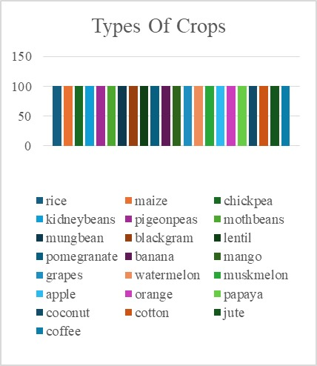

Figure 1 Classification of Crop base on different Categories

3.2 Feature extraction

In this paper, feature extraction is an essential step to ensure precise crop recommendations based on soil and environmental factors. The dataset includes important attributes such as Nitrogen (N), Phosphorus (P), and Potassium (K) levels, which determine soil fertility. Additionally, temperature, humidity, pH, and rainfall are crucial factors that affect crop growth and productivity. These features are carefully selected to identify patterns and relationships between soil properties, climatic conditions, and suitable crops.

To improve the performance of the machine learning model, techniques such as normalization and scaling are applied to maintain uniformity in numerical values. Feature selection is also performed to remove less relevant attributes, ensuring better accuracy and efficiency. By extracting the most significant features, the system can provide accurate crop recommendations based on real-time sensor data. This helps farmers make better agricultural decisions, optimize resource usage, and improve overall productivity.

3.3 Hardware Setup

The hardware setup consists of a pH sensor, an interface board, a microcontroller, a breadboard, and connecting wires. The pH sensor measures the water’s acidity or alkalinity, providing crucial data for determining soil health. This sensor is connected to an interface board that processes the analog signals and converts them into digital values, which can be read by a microcontroller. The ESP8266 microcontroller, known for its Wi-Fi capabilities, is used to collect, process, and transmit the sensor data to a local monitoring system.

A breadboard is used for assembling the circuit without soldering, making modifications and troubleshooting easier. Jumper wires are used to establish connections between components, ensuring efficient data transmission. This setup allows real-time soil monitoring, which helps farmers make informed decisions regarding soil treatment and crop selection. Additionally, integrating this system with a web-based interface enables remote access to soil data, promoting precision agriculture and improving overall productivity.

The implementation of the system starts with assembling all the components on a breadboard, ensuring proper wiring between the pH sensor, interface board, and ESP8266 microcontroller. The microcontroller is programmed using the Arduino IDE to read the sensor data, process it, and convert it into pH values.

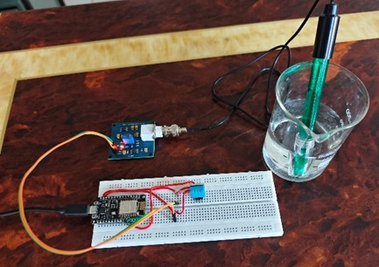

Figure 2 Hardware setup for calculating temperature and humidity

The obtained data is then transmitted wirelessly to a web-based platform for real-time monitoring. To improve accuracy, the pH sensor is calibrated using standard buffer solutions. Additional sensors, such as temperature, humidity can also be integrated to provide a detailed analysis of soil conditions. This setup reduces manual efforts by automating data collection and analysis, allowing farmers to make informed decisions about soil health and crop selection. By enabling continuous monitoring, the system helps improve soil management, optimize resource usage, and enhance agricultural productivity. The hardware setup efficiently integrates a pH sensor, interface board, and ESP8266 microcontroller for real-time soil monitoring. It automates data collection, reducing manual effort and improving accuracy. The system allows easy modifications and can be expanded with additional sensors for better analysis. By providing real-time insights, it helps optimize soil management and crop selection, supporting sustainable and efficient farming practices. pH sensor provided accurate readings, which were validated using standard buffer solutions. The data was successfully transmitted to a web-based platform through the ESP8266 microcontroller, ensuring real-time monitoring. The response time of the system was minimal, allowing quick updates on soil conditions.

**4. Methodology**

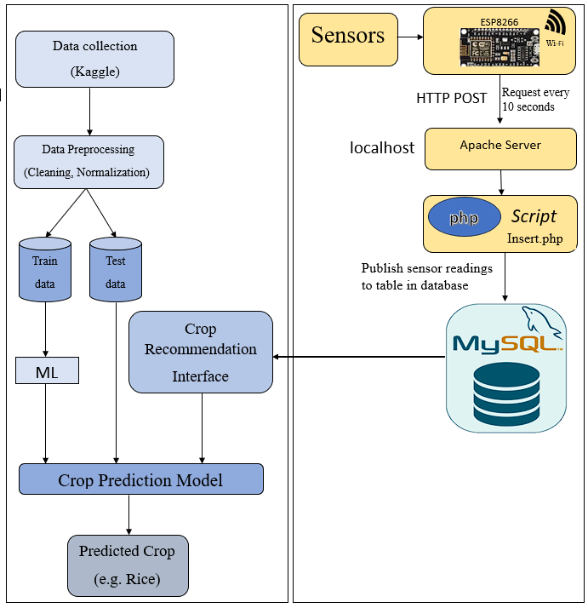

Figure 3 Proposed System Design

4.1 Data Collection

The system begins with the collection of agricultural datasets, primarily sourced from Kaggle . These datasets contain crucial agricultural parameters such as nitrogen , potassium , phosphorus, temperature, humidity, pH level, rainfall. Accurate and diverse data is essential to ensure the machine learning model can learn and generalize well across different environmental conditions.

4.2 Data Preprocessing

Once the raw data is collected, it undergoes preprocessing to ensure it is clean and ready for training. Preprocessing includes data cleaning, where missing or inconsistent values are handled, and normalization, where data is scaled to bring all features to a uniform range. These steps help improve the model’s performance and ensure it can process different datasets efficiently without being biased toward larger numerical values. Proper preprocessing is crucial to avoiding erroneous predictions and enhancing the accuracy of the crop recommendation system.

4.3 Machine Learning Model

After preprocessing, the refined dataset is split into two parts: training data and test data. The training data is used to teach the machine learning model how various environmental factors influence crop suitability. The test data is then used to evaluate the model’s accuracy . The goal is to develop a robust model that can accurately predict the best crop based on real-time input parameters.

4.4 Crop Recommendation Model

The trained machine learning model is then transformed into a crop recommendation model. This model takes user input (such as nitrogen, phosphorous, potassium, pH, temperature, and rainfall) and processes it using the trained ML model to generate a predicted crop recommendation. For example, if the environmental parameters match the optimal conditions for rice, the model will suggest rice as the most suitable crop. The system continuously updates and improves its predictions based on newly collected data, making it more adaptive to changing agricultural conditions.

4.5 Crop Recommendation Interface

The interface acts as the bridge between the user and the prediction model. It allows farmers to input environmental conditions and receive real-time recommendations. This interface is a web application . The interface ensures ease of access and provides a user-friendly experience, allowing farmers to make informed decisions without requiring technical expertise.

4.6 Sensors for Real-Time Data Collection

To enhance the accuracy of the system, IoT-based sensors are deployed in agricultural fields to collect real-time environmental data. These sensors measure crucial parameters such as temperature, humidity, nitrogen, phosphorous, potassium, and pH levels. The collected data is then transmitted to the system every 10 seconds to ensure the most up-to-date information is used for crop recommendation. The integration of IoT with machine learning allows the system to dynamically adjust crop recommendations based on changing field conditions, improving precision in agricultural planning.

4.7 ESP8266 Wi-Fi Module

The ESP8266 microcontroller is used to transmit sensor data to a central server. This module connects to the internet via Wi-Fi and sends sensor readings using HTTP POST requests to the server every 10 seconds. The ESP8266 ensures that data is continuously relayed from the sensors to the system, enabling real-time monitoring of environmental conditions. Its low cost and energy efficiency make it an ideal choice for agricultural IoT applications.

4.8 Apache Server

The Apache server acts as the intermediary between the ESP8266 and the database. It is hosted on a localhost machine and handles incoming sensor data through HTTP requests. Apache ensures that data is properly received, processed, and forwarded to the MySQL database for storage. This server is essential for managing multiple sensor inputs efficiently and ensuring seamless communication between the hardware and software components of the system.

4.9 PHP Script (Insert.php)

A PHP script (Insert.php) is responsible for inserting the data into the MySQL database. When the Apache server receives sensor readings, it passes them to this PHP script, which formats the data appropriately and updates the database in real time. The script ensures that the database is continuously updated with the latest environmental conditions, allowing the crop recommendation model to make accurate predictions based on fresh data.

4.10 MySQL Database

The MySQL database stores all collected environmental data and maintains historical records of sensor readings. This allows for long-term analysis and model improvement over time.The database structure is optimized for quick data retrieval, ensuring that sensor data is instantly accessible when needed for prediction.

**5. Empirical results**

The system was tested to evaluate its performance in measuring water pH and transmitting data wirelessly. The pH sensor provided accurate readings, which were validated using standard buffer solutions. The data was successfully transmitted to a web-based platform through the ESP8266 microcontroller, ensuring real-time monitoring. The response time of the system was minimal, allowing quick updates on soil conditions.

5.1 Performance evaluation

The accuracy of the pH sensor was assessed by comparing its readings with known pH values of standard solutions. The wireless transmission had minimal delays, ensuring real-time data access. The integration of additional sensors, such as temperature and humidity, further improved the system’s capability to provide comprehensive soil analysis.

5.2 Error analysis

Some variations in pH readings were observed due to environmental factors, sensor calibration errors, and fluctuations in soil moisture. Regular calibration using buffer solutions helped minimize errors. The wireless communication was stable, but minor signal interference affected data transmission in certain conditions. These issues can be addressed by improving sensor calibration techniques and optimizing network connectivity. Overall, the system performed efficiently, providing accurate and timely soil data for better agricultural decision-making.

5.3 Implementation:

The graph below shows the accuracy of the model that we have used for crop recommendation.The graph compares the training accuracy of different machine learning classifiers for crop recommendation. Random forest achieved the highest accuracy of 99.31%, followed by KNN with 97% and logistic regression with 95.22%. Decision tree and Naïve Bayes both showed an accuracy of 90%. The results indicate that random forest is the most effective model for crop prediction due to its high accuracy.

Figure 4 Testing accuracy of different Algorithm

The table below displays real-time data gathered through IoT devices, including a DHT11 sensor for measuring temperature and humidity, and a pH sensor module for detecting water acidity. These sensors are connected to a NodeMCU ESP8266, which transmits the collected data to a MySQL database hosted on XAMPP. The database, named "weather," stores key parameters such as temperature, humidity, pH levels, and the exact timestamp of data collection. This real-time data storage helps continuously monitor environmental conditions, providing accurate and up-to-date information essential for making agricultural decisions. After the data is logged into the database, it is retrieved using PHP and displayed on a web page in a neatly organized table. This setup allows users, including farmers, to access live sensor readings directly through a web browser, making the system easy to use and highly accessible. The integration of MySQL and PHP ensures the web page automatically updates with the latest sensor data, eliminating the need for manual refreshes. This seamless connection between hardware components (sensors and microcontroller) and software elements (database and web interface) results in an efficient system for monitoring environmental factors, supporting better decision-making for crop recommendations and soil management.

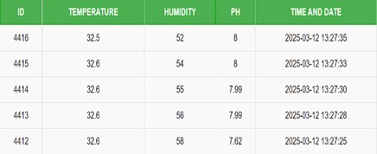

Figure 5 Sensor Values

The below figure illustrates the web interface of a crop recommendation system designed to assist farmers in selecting the most suitable crop based on real-time environmental and soil conditions. The system captures essential parameters like nitrogen, phosphorus, potassium, temperature, humidity, pH, and rainfall. After entering these values and clicking submit, the system processes the data and provides a crop recommendation here it is given as rice. This recommendation is based on a machine learning model that evaluates the input values to guide farmers toward informed agricultural decisions. By leveraging real-time data, the system supports precision farming, helping to improve crop yields and reduce the likelihood of crop failure.

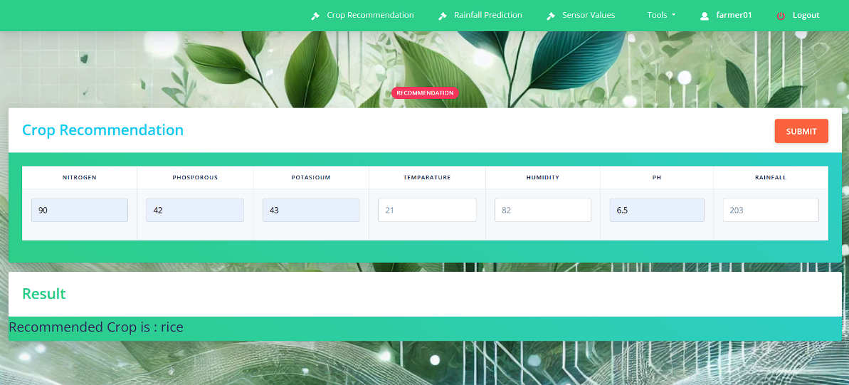

Figure 6 Crop Recommendation System

**6. Conclusion**

The proposed crop recommendation system integrates Machine Learning and IoT to assist farmers in selecting the most suitable crops based on real-time soil and environmental conditions. By utilizing sensors such as pH, temperature, and humidity the system collects accurate data, which is then processed using ML algorithms like Random Forest, Decision Tree, Naive Bayes, and KNN. This approach improves decision-making, enhances agricultural productivity, and promotes sustainable farming practices. The system minimizes manual effort, optimizes resource utilization, and reduces the risks associated with unpredictable environmental changes. Future enhancements can include expanding the dataset, incorporating advanced predictive models, and improving wireless connectivity for seamless real-time monitoring. This research contributes to precision agriculture by providing an efficient and data-driven solution for better crop selection and farm management.

**Acknowledgment**

We express our sincere gratitude to our team members and our guide Prof. Viki Patil and Prof. Mahesh Pawaskar for their invaluable contributions to the development of this manuscript and the successful completion of our research project. Their dedication, support, and expertise have been instrumental in every stage of this endeavor. We also acknowledge that this research was self-funded, and no external sponsorship was involved.

**7. References**

1. C. V. Neha Niharika, K. Mothish Kumar, K. Harika, V. Venkatesh and A. Y. Begum, "Crop Recommendation with IOT and ML," 2023 4th International Conference for Emerging Technology (INCET), Belgaum, India, 2023, pp. 1-5, doi: 10.1109/INCET57972.2023.10170561.
2. A. A. Islam Ridoy, M. A. Ismail Siddique and O. Joyti, "A Machine Learning-Driven Crop Recommendation System with IoT Integration," 2024 6th International Conference on Electrical Engineering and Information & Communication Technology (ICEEICT), Dhaka, Bangladesh, 2024, pp. 812-817, doi: 10.1109/ICEEICT62016.2024.10534479.
3. J. S. Jeyanathan, B. Veerasamy, B. Medha, G. T. V. Sai, R. B. Kumar and V. Sahu, "Design of Crop Recommender System using Machine Learning and IoT," 2023 7th International Conference on Trends in Electronics and Informatics (ICOEI), Tirunelveli, India, 2023, pp. 1127-1132, doi: 10.1109/ICOEI56765.2023.10125963.
4. Davrazos, Gregory & Panagiotakopoulos, Theodor & Kotsiantis, Sotiris & Kameas, Achilles. (2023). IoT-Enabled Crop Recommendation in Smart Agriculture Using Machine Learning. 1-4. 10.1109/IISA59645.2023.10345924.
5. H. S. Negi and S. C. Dimri, "Machine Learning Enabled Smart Farming:The Demand of the Time," 2022 Seventh International Conference on Parallel, Distributed and Grid Computing (PDGC), Solan, Himachal Pradesh, India, 2022, pp. 490-495, doi: 10.1109/PDGC56933.2022.10053335.
6. M. S. Kumar, S. Girinath, G. G. V. S. Lakshmi, A. V. S. Ganesh and K. J. Kumar, "Crop Yield Prediction Using Machine Learning," 2023 International Conference on Sustainable Emerging Innovations in Engineering and Technology (ICSEIET), Ghaziabad, India, 2023, pp. 569-573, doi: 10.1109/ICSEIET58677.2023.10303423.
7. A. Mewar, K. Riyal, R. Vyas, R. Agrawal and C. Dhule, "Design of Web Based Recommendation System for Farmers using Machine Learning," 2024 International Conference on Innovations and Challenges in Emerging Technologies (ICICET), Nagpur, India, 2024, pp. 1-6, doi: 10.1109/ICICET59348.2024.10616309.
8. A. Kayum and M. O. Rahman, "Appropriate Crop Recommended System for Cultivation using IoT and ML," 2023 5th International Conference on Sustainable Technologies for Industry 5.0 (STI), Dhaka, Bangladesh, 2023, pp. 1-6, doi: 10.1109/STI59863.2023.10464865.
9. C. N, A. Chinnasamy and M. Ashok, "Enhancing Agricultural Yield Predictions with Real-Time IoT Sensor Data and Machine Learning Integration," 2024 International Conference on IoT Based Control Networks and Intelligent Systems (ICICNIS), Bengaluru, India, 2024, pp. 335-341, doi: 10.1109/ICICNIS64247.2024.10823110.
10. S. Balaji, N. K. K. Raju, S. Tarun, R. Karthikeyan, T. Shankar and R. Santhakumar, "Precision Agriculture Crop Recommendation System Using IoT and Machine Learning," 2023 2nd International Conference on Vision Towards Emerging Trends in Communication and Networking Technologies (ViTECoN), Vellore, India, 2023, pp. 1-6, doi: 10.1109/ViTECoN58111.2023.10157577.
11. A. Dahane, R. Benameur, B. Kechar and A. Benyamina, "An IoT Based Smart Farming System Using Machine Learning," 2020 International Symposium on Networks, Computers and Communications (ISNCC), Montreal, QC, Canada, 2020, pp. 1-6, doi: 10.1109/ISNCC49221.2020.9297341.
12. K. S. Pratyush Reddy, Y. M. Roopa, K. Rajeev L.N. and N. S. Nandan, "IoT based Smart Agriculture using Machine Learning," 2020 Second International Conference on Inventive Research in Computing Applications (ICIRCA), Coimbatore, India, 2020, pp. 130-134, doi: 10.1109/ICIRCA48905.2020.9183373.
13. A. Suresh, B. Geetha Vani, M. Lavanya and R. G. Kumar, "A Hybrid IoT and Machine Learning Approach for Crop Recommendation Using a Voting Ensemble Model," 2024 International Conference on Integrated Circuits and Communication Systems (ICICACS), Raichur, India, 2024, pp. 1-7, doi: 10.1109/ICICACS60521.2024.10498984.
14. A. Chauhan, A. Tsunduru, K. Parveen, S. Tokala, K. Hajarathaiah and M. K. Enduri, "A Crop Recommendation System Based on Nutrients and Environmental Factors Using Machine Learning Models and IoT," 2023 International Conference on Information Technology (ICIT), Amman, Jordan, 2023, pp. 453-458, doi: 10.1109/ICIT58056.2023.10226131.
15. <https://www.kaggle.com/datasets/atharvaingle/crop-recommendation-dataset?resource=download/>